

PharmaLine Requirements Specification

June 5, 2023

Group Members:

Aurora Mana

Tea Begaj

Huerta Kalaci

Rigersa Bicaku

Kleo Mitri

Kristjan Kusta

**Table of Contents**

**PHARMALINE REQUIREMENTS SPECIFICATION 1**

**VERSION 1.0 1**

**JUNE 5, 2023 1**

**1.** **EXECUTIVE SUMMARY 3**

1.1 Project Overview 3

1.2 Purpose and Scope of this Specification 3

**2.** **PRODUCT/SERVICE DESCRIPTION 4**

2.1 Product Context 4

2.2 User Characteristics 5

2.3 Assumptions 6

2.4 Constraints 6

2.5 Dependencies 7

**3.** **REQUIREMENTS 7**

3.1 Functional Requirements 7

3.2 Non-Functional Requirements 12

*3.2.1* *Product Requirements 12*

**3.2.1.1** **User Interface Requirements** 12

**3.2.1.2** **Usability** 13

**3.2.1.3** **Efficiency** 14

3.2.1.3.1 Performance Requirements 15

3.2.1.3.2 Responsiveness 16

**3.2.1.4** **Dependability** 16

**3.2.1.5** **Security** 16

*3.2.2* *Organizational Requirements 16*

**3.2.2.1** **Environmental Requirements** 16

**3.2.2.2** **Operational Requirements** 17

**3.2.2.3** **Development Requirements** 17

*3.2.3* *External Requirements 17*

**3.2.3.1** **Regulatory Requirements** 17

**3.2.3.2** **Ethical Requirements** 18

**3.2.3.3** **Legislative Requirements** 18

3.2.3.3.1 Accounting Requirements 18

3.2.3.3.2 Security Requirements 18

3.3 Domain Requirements 19

**4.** **SOFTWARE DESIGN 19**

4.1 use cases 19

4.2activity diagrams 25

4.3state diagrams 36

4.4sequence diagrams 44

4.5class diagrams 51

4.6communication diagrams 55

# 1. Executive Summary

## Project Overview

PharmaLine is a user-friendly, convenient and accessible application that aims to make shopping for pharmaceutical products more efficient for all its users. Our app caters to different user levels, including customers, clerks, managers and the business owner, ensuring that each user can access the functionalities they need based on their access level.

For customers, the application will allow them to browse for products and place orders quickly and easily with just a simple click, erasing the need of visiting multiple shops. They can also comment and rate a product based on their experience, view their profile which includes a purchase history of the items ordered, and have multiple payment options including credit cards, debit cards, and digital wallets to accommodate customers' different preferences. The application also offers a Wishlist feature that allows customers to order products in advance that are currently out of stock or unavailable for any other reason.

For clerks and managers, the application provides better inventory management tools and organized sales data, making it easier for them to aid clients and more. They have the option of adding and removing products, with the clerk being more involved in this role. They can also check daily sales and the list of products displayed on the page, the number of products per category, and how many products are currently available. Both the owner and manager have the option of checking monthly sales reports.

The system also includes customized recommendations based on the customer's purchase history or search history. For example, if a customer has previously purchased cold and flu medication, the system can recommend them other cold and flu-related products. The application also provides product availability notifications to customers when products they have shown interest in are back in stock or available for purchase. Customers can track the status of their orders in real-time, including when they have been shipped and estimated delivery dates. The system also allows customers to compare products side-by-side based on features, price, and other factors.

The application also includes a store locator feature that shows customers the nearest physical store location based on their location. It integrates with social media platforms to allow customers to share their favorite products or promotions with their friends and followers. Additionally, the system can integrate with chatbots to provide customers with instant support and assistance. Customers have the option of referring their friends to the store through the referral program, receiving rewards for each successful referral.

Overall, PharmaLine is designed to provide an efficient and effective solution for customers, clerks, managers and the business owner, ensuring that everyone benefits from the ease and convenience of the application. It aims to revolutionize the way people shop for pharmaceutical products, providing a more accessible, convenient, and user-friendly experience.

## Purpose and Scope of this Specification

The purpose of this specification is to assess the current state of the product design and to document the entire process based on design issues and the audience.

This specification encompasses several aspects of the process being discussed in as broad scope as possible. Thus, in this scope we address the following:

* In depth documentation of the features of the product,
* Technical overview of the system processes and views,
* This is discussed in Part 2.1 and throughout the document,
* User and System Requirements,
* Components & Functional/non-functional requirements,
* These are discussed in Part 3 in some detail,
* Definition of users’ means of using and accessing the product,
* Use cases/scenarios discussed in Part 4,
* Dependencies and Constraints,
* These are discussed in Part 2.4/5 of the Document,

Aspects not included in the scope are as follows:

* Legislative requirements for the product
* Auditing and financial considerations of the product

# Product/Service Description

This app is designed to provide an easy and efficient way for users to purchase medicine and skincare products. Users can browse through a wide selection of products and place orders with just a few taps on their phone. Additionally, users can bookmark items and set a reminder to repurchase at a later date.

For clerks, the app provides an intuitive interface for managing inventory, processing orders, and tracking shipments. The app makes it easy to add new products, update prices, and manage stock levels.

For managers and owners, the app provides access to real-time sales data, inventory reports, and customer feedback. The app also makes it easy to manage promotions and discounts, as well as track the performance of individual products. Overall, the app streamlines the process of buying and selling medicine and skincare products for both consumers and businesses.

## Product Context

## PharmaLine is a revolutionary application designed to make shopping for pharmaceutical products more accessible and convenient. Its purpose is to simplify the process of purchasing prescription medication and over-the-counter drugs, while also providing a comprehensive resource for clients and healthcare professionals.

## PharmaLine is designed with the user in mind and is focused on providing a high level of accessibility and convenience. It offers an intuitive interface that makes it easy to search for and purchase the products that clients need. The application also provides a wealth of information on the medications, including dosage, side effects, and potential interactions with other drugs.

## By offering a cloud-based solution, PharmaLine eliminates the need for patients to visit multiple pharmacies in person or make phone calls to check availability or prices. The application allows clients to easily access a wide range of pharmaceutical products.

## With PharmaLine, client can rest assured that their medical information is kept secure and private. The application is compliant with all necessary regulations and provides a safe and secure platform for clients to manage their healthcare needs.

## PharmaLine is a game-changer for the pharmaceutical industry, offering a more accessible, convenient, and user-friendly solution for clients and healthcare professionals.

## User Characteristics

**Customers:**

* Can use PharmaLine to browse and purchase pharmaceutical items
* Checks purchase history and gives feedback on items
* Rates items based on personal experience
* Uses a wishlist to pre-order items that are out of stock or unavailable
* Makes use of personalized product suggestions
* Pays using a variety of payment methods, including credit cards, debit cards, and digital wallets
* Tracks orders and compares products
* Interacts with social networking platforms through the app
* Can be use by wide range of individuals from teenagers to elderly people
* Elderly people who may have mobility or transportation issues and prefer the convenience of ordering their medications online and they can also save time by bookmarking items and setting reminders to purchase them at a later date.
* Teenagers or adults who can be more interested in skincare and want to browse for items, leave comments, and read reviews.

**Managers:**

* Add or delete offers and discounts in the blog section
* Manage the inventory and product listings
* Check daily sales and monthly sales reports
* Administer the blog section

**For Clerks:**

* Check the items bought by a single user or the list of purchasers for a particular product
* Add and delete products
* Inspect product listings and availability
* Help customers with any issues related to the app

**Business Owners:**

* Access all features available to managers and clerks
* Monitor the overall performance of the store
* Make strategic decisions based on the sales data and user feedback

## Assumptions

* It is presumed that every user is familiar with the fundamentals of handling electronic equipment (e.g., smartphones, tablets, computers, etc.).
* In order to access the webpage, the electronic device must be online.
* Electronic devices are assumed to one of the after mentioned operating systems: Microsoft Windows, Android OS and Apple IOS.
* Users of all ages should be able to quickly navigate the website thanks to its simple and user-friendly interface.
* User data that is entered or collected by the system, is assumed to only be used by the shipment company.
* It is assumed that the team won't falter along the road and that the project's cost won't fluctuate during development.

## Constraints

There are a number of items that will likely constrain the design options, including:

* The diverse age target, our system is aimed at both younger and older audiences, ranging from teenagers to the elderly, which creates issues regarding the design of a user-interface modern enough to entertain the youth, while simultaneously being easy to use for our older clientele.
* Every clerk, manager and the owner must log in/register with their personal username in order to carry out their respective duties, as aforementioned in the user characteristics section.
* There should be provided fast internet connection so the app can work properly.
* Costumer log in is optional, however required if the user is interested in notifications regarding their medicine refill, discount offers, and having a place in the ranking list.

## Dependencies

* Users must log in to access their account information and personalized features.
* The app must have access to real-time inventory data from the shops to ensure accurate product information.
* The app must be able to process multiple payment options including credit cards, debit cards, and digital wallets.
* The clerk and manager must have the ability to add and remove products from the inventory.
* The manager and owner must be able to access daily sales data, monthly reports, and manage the blog section.
* The system must provide customized recommendations to customers based on their purchase and search history.
* The system must be able to track the status of orders and provide real-time updates to customers.
* The app must have a store locator feature that shows customers the nearest physical store location based on their location.
* The system must integrate with social media platforms to allow customers to share their favorite products or promotions with their friends and followers.
* The system must integrate with chatbots to provide customers with instant support and assistance.
* The referral program should be implemented to reward customers who refer their friends to the store.
* The app must have a reliable internet connection to function properly.
* The app must be compatible with the latest mobile devices and operating systems.
* Proper training must be provided to the staff to ensure they can effectively use the inventory management tools and sales data provided by the app.

These dependencies are critical to the functionality of the app, and failure to meet these requirements can result in a negative customer experience, loss of sales, and reduced efficiency for the shop personnel. Therefore, it is essential to carefully consider these dependencies during the development and implementation process of the PharmaLine application.

# Requirements

## Functional Requirements

| **Req#** | **Requirement** | **Comments** | **Priority** | **Date Rvwd** | **SME Reviewed / Approved** |
| --- | --- | --- | --- | --- | --- |
| R_01 | The system must allow the user to login and register. | Logging in or creating an account by verifying the entered credentials should be done by the system. | 1 | 08.05.2023 | Huerta Kalaci  Aurora Mana |
| R_02 | User must be able to log in through an email and a password they have provided during registry. |  | 1 | 08.05.2023 | Huerta Kalaci |
| R_03 | The system must offer different views and options for different user levels. | Based on the user level the webpage will present different views/options. | 1 | 08.05.2023 | Huerta Kalaci |
| R_04 | All user levels must be able to search through the product list. | The webpage should have an input field, preferably a search bar, where the user can look up a product. This should be accessible even for logged off/anonymous users. | 1 | 08.05.2023 | Huerta Kalaci  Rigersa Biçaku |
| R_05 | System should allow logged in customers to leave comments and reviews on products. |  | 2 | 10.05.2023 | Aurora Mana  Tea Begaj |
| R_06 | System should save the purchase data of an account. | Customers should have the option to check their purchase history, for products they may have purchased when they were logged in. | 3 | 10.05.2023 | Rigersa Biçaku |
| R_07 | System must offer multiple payment options to customers. | Customers should be allowed to use credit card, debit cards, and crypto cards to make an online purchase. | 1 | 10.05.2023 | Kristjan Kuska |
| R_08 | Logged in customers, should be allowed to save certain products in their Wishlist. |  | 3 | 11.05.2023 | Kleo Mitri  Kristjan Kuska |
| R_09 | Logged in customers should have the option to view their wish list. |  | 3 | 11.05.2023 | Kristjan Kuska |
| R_10 | Clerk and Manager users must be allowed to add products in the database. | It is expected that logged in managers and clerks will have an option available, where they can add new products into the database. The new products should be available to all user levels. | 1 | 11.05.2023 | Huerta Kalaci  Rigersa Biçaku |
| R_11 | Clerk and Manager users must be allowed to make any additional changes to existing products of the database. | It is expected that logged in managers and clerks will have an option to edit a products information. | 1 | 11.05.2023 | Tea Begaj |
| R_12 | The system should be able to provide a daily sales report to Managers and Admins/Owners. | This option should be available only for these two user levels. | 2 | 11.05.2023 | Aurora Mana |
| R_13 | The system must allow Managers to access the full list of products located in the database. | Managers should be able to view all products, even those who have been flagged as out of stock. | 2 | 11.05.2023 | Kleo Mitri  Rigersa Biçaku |
| R_14 | The system must be able to provide a monthly report to Managers and Admins/Owners. | This option should be available only for these two user levels. | 1 | 12.05.2023 | Kristjan Kuska  Huerta Kalaci |
| R_15 | Admins/Owners should have an option available that allows them to edit the websites main blog. |  | 3 | 12.05.2023 | Tea Begaj |
| R_16 | Admins/Owners must have an option available that allow them to create discount codes. | Admins/Owners should be able to create discount codes and declare their active period. | 1 | 13.05.2023 | Huerta Kalaci |
| R_17 | Admins/Owners should have an option to flag a product as the product of the day. |  | 3 | 13.05.2023 | Rigersa Biçaku |
| R_18 | Managers should be able to check products purchased by specific customers. | The user info accessible by the manager should only be the customers username, email and order information. | 2 | 13.05.2023 | Aurora Mana |
| R_19 | Managers should be able to check a list of buyers for a specific product. |  | 2 | 13.05.2023 | Kleo Mitri |
| R_20 | The system should be able to customize a customer’s recommendations based on their searched products. |  | 2 | 13.05.2023 | Kristjan Kuska |
| R_21 | The system should allow the customer to flag a unavailable product. | This way the user can be notified when that product is back in stock. | 2 | 13.05.2023 | Huerta Kalaci |
| R_22 | The system should send a notification to a customer when a flagged product has been restocked. |  | 2 | 13.05.2023 | Rigersa Biçaku |
| R_23 | The system should provide an order tracking option. | The customer should be able to see the status of their order | 3 | 13.05.2023 | Kleo Mirti |
| R_24 | The system should have an option that allows a customer, logged in or logged out, to compare two products side by side on the screen. |  | 3 | 14.05.2023 | Tea Begaj |
| R_25 | There should be an option available on each product page, where the user can share the product in other social platforms. |  | 3 | 14.05.2023 | Kristjan Kuska |
| R_26 | An option should be available to all user levels, where they can report certain bugs or issues they seem to be facing. | There should be a form filled out, where the user describes the problem, they seem to be facing. The problem can be related to the backend or the frontend issues. | 1 | 14.05.2023 | Aurora Mana  Huerta Kalaci |
| R_27 | The system should have an AI option, where the user can ask general questions regarding a product or on how to do an action. |  | 3 | 14.05.2023 | Kristjan Kuska |
| R_28 | The system should provide customized product recommendations based on the customer's purchase history or search history. |  | 2 | 14.05.2023 | Rigersa Biçaku  Kleo Mitri |
| R_29 | The system should support multiple payment options, including credit cards, debit cards, and digital wallets, to accommodate customers' preferences. |  | 1 | 14.05.2023 | Huerta Kalaci  Tea Begaj |
| R_30 | The system should include a blog management feature where the owner can add and remove offers, choose the product of the day, and display available discounts. |  | 1 | 14.05.2023 | Kleo Mitri  Aurora Mana |
| R_31 | The system should allow the manager to check the products purchased by a specific user, with only the username displayed for privacy reasons. |  | 3 | 14.05.2023 | Kristjan Kuska |
| R_32 | The system should allow the manager to check the list of buyers for a specific product, with only the username displayed for privacy reasons. |  | 3 | 14.05.2023 | Rigersa Biçaku |
| R_33 | The system should provide a referral program where customers can refer their friends to the store and receive rewards for each successful referral. |  | 2 | 14.05.2023 | Tea Begaj |
| R_34 | The system should implement a chatbot feature to provide customers with instant support and assistance. |  | 2 | 14.05.2023 | Kristjan Kuska |
| R_35 | The system should integrate with social media platforms to allow customers to share their favorite products or promotions with their friends and followers. |  | 2 | 14.05.2023 | Kleo Mitri  Rigersa Biçaku |
| R_36 | The system should include a store locator feature that shows customers the nearest physical store location based on their current location. |  | 2 | 14.05.2023 | Aurora Mana  Tea Begaj |
| R_37 | The system should provide real-time updates on the status of customer orders, including shipping updates and estimated delivery dates. |  | 1 | 14.05.2023 | Huerta Kalaci |
| R_38 | The system should allow customers to compare products side-by-side based on features, price, and other factors. |  | 2 | 14.05.2023 | Kristjan Kuska |
| R_39 | The system should send notifications to customers when products they have shown interest in are back in stock or available for purchase. |  | 2 | 14.05.2023 | Tea Begaj |
| R_40 | The system should offer a personalized shopping experience. Based on the customer's preferences, browsing history, and previous purchases, the system should provide personalized product recommendations, customized promotions, and tailored content to enhance the overall shopping experience. |  | 1 | 14.05.2023 | Rigersa Biçaku  Huerta Kalaci |

## Non-Functional Requirements

***3.2.1.1 User interface requirements***

The user interface of PharmaLine will be designed to cater to different user levels, providing a seamless and intuitive experience. The interface will be grouped into three main categories based on the user's role: customer, clerk, and manager/business owner. The following descriptions outline the key elements of each interface:

**Logged-in Interface:**

* This interface will be accessible to all types of users.
* Users will enter their login credentials, including username and password, in the provided input boxes.
* A submit button will be available to log in and access the other pages of the application.

**Customer Interface:**

* The customer interface will provide a user-friendly experience for customers.
* The home page will display three categories, represented by icons and labels, allowing customers to navigate to different pages with various functionalities.
* A navigation bar will be placed at the top for quick access to different sections of the app.
* In the product browsing and ordering section, customers can search for products and place orders with a simple click.
* Customers will have the ability to leave comments and rate products based on their experience.
* A profile page will display the customer's purchase history, including a list of items ordered.
* Multiple payment options, such as credit cards, debit cards, and digital wallets, will be available to accommodate different customer preferences.
* Customers can create a wishlist to order products in advance that are currently out of stock or unavailable.
* The communication section will provide a chat icon for customers to communicate with dermatologists or support staff for assistance.

**Clerk Interface:**

* The clerk interface will primarily focus on inventory management and order processing.
* Clerks will have the option to add and remove products from the inventory.
* They will be responsible for confirming orders placed by customers.
* Additionally, clerks will have access to daily sales records to monitor and manage sales data effectively.

**Manager/Business Owner Interface:**

* The manager/business owner interface will provide comprehensive tools for managing the business operations.
* Managers and owners can check the list of products displayed on the app, view the number of products per category, and track the current availability of products.
* Monthly sales reports will be accessible to both managers and owners for performance analysis.
* The interface will allow managers and owners to manage the blog section, including adding and removing offers, selecting the favorite product of the day, and showcasing available discounts.
* Managers can view the products purchased by specific customers (with only the username displayed for privacy reasons) and check the list of buyers for a specific product.
* The system will provide customized recommendations based on customer purchase history or search history.
* Customers will receive product availability notifications when items they have shown interest in are back in stock or available for purchase.
* The order tracking feature will provide real-time updates on the status of customer orders, including shipment details and estimated delivery dates.
* Customers will have the ability to compare products side-by-side based on features, price, and other factors.
* The system will include a store locator feature that shows customers the nearest physical store location based on their current location.
* Integration with social media platforms will enable customers to share their favorite products or promotions with friends and followers.
* Integration with chatbots will provide instant support and assistance to customers.
* Multiple payment options, including credit cards, debit cards, and digital wallets, will be supported to accommodate customer preferences.
* A referral program can be implemented where customers can refer friends to the store and receive rewards for successful referrals.

*By considering these user interface requirements, PharmaLine can provide a user-friendly and efficient experience for customers, clerks, managers, and business owners.*

***3.2.1.2 Usability***

Usability is a crucial aspect of the PharmaLine application, ensuring that it is user-friendly and efficient for both customers and staff. The following key indicators contribute to the usability of the application:

Accessibility:

PharmaLine must be accessible remotely and available at all times since both customers and dermatologists will use the app on their devices. Users should be able to access the application easily, regardless of their location or time.

Responsiveness:

The design and database of the app should be highly responsive. This means that the user interface should provide a smooth and seamless experience, with fast loading times and minimal lag. Data transactions, such as searching for products and placing orders, should be efficient and completed in a timely manner.

Flexibility:

The application should be designed with flexibility in mind, allowing for easy updates and adaptations to meet evolving requirements. This ensures that new features can be added, existing functionalities can be improved, and the application can keep up with changing user needs and industry standards.

Fault Detection and Handling:

To maintain a high level of usability, the application should be designed to detect and handle faults promptly. Error handling mechanisms should be in place to provide users with clear and meaningful error messages when they encounter issues. The application should also have robust error tracking and logging capabilities to facilitate efficient debugging and problem resolution.

Effectiveness:

PharmaLine should be designed to be simple and easy to use for both customers and dermatologists. The user interface should be intuitive, with clear navigation and logical organization of features. This allows users to accomplish tasks without confusion or unnecessary steps, enhancing their overall experience.

Efficiency:

The application should enable users to perform tasks effortlessly and with minimal errors. User interactions, such as browsing for products, placing orders, and managing inventory, should be streamlined and optimized for efficiency. This includes reducing the number of clicks or steps required to complete actions, providing shortcuts or quick access to frequently used features, and minimizing waiting times for data retrieval or processing.

*By prioritizing usability, PharmaLine can deliver a user-friendly experience that maximizes customer satisfaction and efficiency for both customers and staff.*  
 ***3.2.1.3 Efficiency***

PharmaLine aims to provide users with a highly efficient experience, ensuring that tasks can be completed effortlessly, with minimal errors, and in a short amount of time. The following considerations address the efficiency requirements:

* Real-time operations: Each task should be executed instantly, providing a seamless user experience.
* Easy browsing and ordering: Customers can effortlessly search for products and place orders with a simple click, eliminating the need to visit multiple shops.
* Efficient inventory management: The app provides shop personnel with better tools for inventory management and organized sales data, enabling them to assist clients more effectively.
* User-specific updates: Once users are identified, their main page is updated according to their access level, enhancing efficiency in accessing relevant information.
* Multiple payment options: Customers have the flexibility to choose from various payment methods, accommodating their preferences and streamlining the purchasing process.
* Advanced ordering: Users can order products in advance, even if they are currently out of stock or unavailable, through the Wishlist feature.
* Easy product management: Clerks and managers have the option to add and remove products, simplifying inventory management tasks.
* Sales monitoring: Managers and owners can efficiently check daily sales, as well as monthly reports for a comprehensive overview of performance.
* Product availability notifications: Customers receive timely notifications when products they have shown interest in are back in stock or available for purchase, improving efficiency in making informed buying decisions.
* Real-time order tracking: The system provides customers with real-time updates on order statuses, including shipping progress and estimated delivery dates, ensuring transparency and convenience.
* Product comparison: Customers can compare products side-by-side based on features, price, and other factors, enabling them to make well-informed purchasing decisions efficiently.
* Store locator: The system includes a store locator feature that shows customers the nearest physical store based on their location, facilitating convenience and accessibility.
* Integration with social media: The system integrates with social media platforms, allowing customers to easily share their favorite products or promotions with their friends and followers, expanding reach and engagement.
* Chatbot integration: The system integrates chatbots to provide customers with instant support and assistance, improving response times and overall user satisfaction.
* Referral program: A referral program is implemented, encouraging customers to refer friends and receive rewards, promoting customer engagement and loyalty.

***3.2.1.3.1 Performance Requirements***The software will be developed as a mobile app for users, and as a web-based application for administrators.

The software application should be designed to support all users with an account at any time they want to access it.

While the app requires an internet connection to fully utilize its functionalities, there should be certain features or functionalities that can be accessed offline, without an internet connection.

***3.2.1.3.2 Responsiveness***

The application should be highly responsive to user input and external interruptions. It should promptly and efficiently respond to user actions, ensuring a smooth and seamless user experience.

In cases where the application is interrupted by another activity or app, it should save its current state and return to the same state or page when the interruption is resolved, providing continuity to the user.

***3.2.1.4 Dependability and Availability***

The application may have limited availability or functionality if users do not have an internet network connection. It should provide clear notifications or messaging to users in such situations, informing them about the limited functionality and the need for an internet connection to access all features.

The application should strive to be available to users at all times, ensuring high uptime and minimal downtime. It should be designed to handle high user traffic and maintain stability and responsiveness under varying load conditions.

While the application aims to provide services to users in any geographical area, it may have limitations in offering certain services to patients who are located abroad. Clear communication should be provided to users regarding the availability and limitations of services based on their geographical location.

***3.2.1.5 Security***

* Each user is responsible for their personal data authenticity that is entered during registration.
* User’s will be guided to create a good and strong password as a proactive measure to protect themselves.
* User’s password will be encrypted and then saved into the database.
* A customer’s credit card details won’t be saved in the system.
* A customer’s address won’t be saved in the system, but it will be sent to a third-part shipment company.
* The option to add or edit any existing products in the database should only be accessible to clerks and managers.
* The option to check sale repost should be accessible only by managers and owner.

***3.2.2. Organizational Requirements***

***3.2.2.1 Environmental Requirements***

For the system to function the user must be connected to a Wi-Fi network. When a person makes changes to their personal information, such as their surname, they should log in into their account and do these changes manually. This is done to ensure a better experience for the users. Customer shipment information should not be saved in the database/system and should only be sent to a third-party shipment service.

***3.2.2.2 Operational Requirements***

* The webpage should be available to all users 24/7, unless in cases of maintenance.
* A customer should be able to self-delete their account.
* Accounts such as clerk and manager can only be deleted by the owner.
* A customers Wishlist may experience changes, such as addition or deletion, only with the approval of the customer.
* Data integrity of a new product must be done manually by the clerk or the manager, but the system will provide a few hints when the information is inserted. This means that when the clerk or manager wants to insert a new products barcode, the system will check the input an alert the user if the barcode field has less than 12 digits.
* Before an order is finalized and the shipment information is sent over to the shipment company, the clerk must first confirm the order.

#### ***3.2.2.3 Development Requirements***

User-friendly Interface: The platform should have an intuitive and easy-to-use interface, ensuring smooth navigation for users.

Secure Data Management: Implement robust security measures to protect user information, including encryption protocols, secure storage, and secure data transmission.

Mobile Compatibility: Develop a responsive design that allows seamless access and functionality across various devices, including desktops, smartphones, and tablets.

Efficient Search and Filtering: Provide a comprehensive search functionality and filtering options for users to find medications easily.

Prescription Management: Incorporate a system for users to upload and manage their prescriptions securely, ensuring compliance with legal and regulatory requirements.

Order Tracking and Status Updates: Enable users to track their orders and receive regular updates on the status of their purchases.

Payment Gateway Integration: Integrate secure payment gateways to facilitate smooth and secure transactions.

Inventory Management: Implement a robust inventory management system to track stock levels, expiry dates, and ensure availability of medications.

#### ***3.2.. External Requirements***

***3.2.3.1 Regulatory Requirements***

Compliance with Pharmaceutical Regulations: Ensure adherence to local, regional, and international regulations related to online pharmacies, including licensing, permits, and certifications.

Prescription Verification: Establish processes to verify and authenticate prescriptions, ensuring they are legitimate and issued by authorized healthcare professionals.

Privacy and Data Protection: Comply with data protection laws and regulations, including obtaining user consent, handling personal and medical information securely, and providing clear privacy policies.

Product Authentication and Quality Assurance: Establish procedures to verify the authenticity and quality of pharmaceutical products being sold on the platform, including sourcing from reliable suppliers

and conducting regular quality checks.

Adverse Event Reporting: Develop a mechanism for users to report any adverse reactions or incidents related to medications purchased through the platform, in compliance with pharmacovigilance regulations.

***3.2.3.2 Ethical Requirements***

Patient Confidentiality: Safeguard user privacy and maintain strict confidentiality of personal health

information, following ethical guidelines and regulations.

Professionalism and Integrity: Uphold ethical standards in all aspects of the business, including honest advertising, accurate product information, and fair pricing practices.

Responsible Marketing and Promotion: Adhere to ethical guidelines in advertising and promotional activities, ensuring the information provided is accurate, balanced, and transparent.

Transparent Pricing: Clearly display prices of medications, including any additional fees or charges, to avoid misleading customers.

Prohibition of Counterfeit Products: Take strict measures to prevent the sale of counterfeit or substandard medications, protecting the health and well-being of users.

***3.2.3.3 Legislative Requirements***

The power of legislation and regulation in the context of PharmaLine includes:

* Creating and recognizing rights for users, such as privacy protections and consumer rights. Imposing obligations and penalties on vendors, clinics, and other stakeholders to ensure compliance with legal and regulatory requirements.
* Establishing permanent institutions and institutional arrangements to oversee and regulate the healthcare system, including aspects related to planning, financing, service provision, integrity, and supervision.

Considerations related to legislation and regulation in the development and operation of PharmaLine:

* Compliance with legal laws and requirements that govern the operations of the app, ensuring accountability and legal authority for key healthcare functions.
* Adhering to legislative standards to ensure patient safety, particularly when decision assistance software is used in the clinical setting.
* Understanding the legal scenarios where liability could arise, such as in the case of patient injuries caused by embedded software in medical devices or decision support software.

It is crucial for key players involved in PharmaLine to be aware of and adhere to the relevant legislation and regulations to ensure the application operates within legal boundaries and promotes safety, security, and accountability for all stakeholders.

##### Accounting Requirements

Accounting Requirements include:

* Accurate financial tracking and recording
* Generation of financial reports and analytics
* Seamless integration with payment gateways
* Privacy and security of financial data
* Compliance with accounting standards and regulations

These requirements ensure proper financial management, transparency, and compliance within PharmaLine's operations.

##### Security Requirements

Security Requirements:

* Compliance with relevant data protection regulations: The personal information of every user will be protected according to the applicable data protection regulations and legislative standards.
* User access control: The system should provide secure user authentication and access control mechanisms to ensure that only authorized individuals can access and perform actions based on their assigned roles and privileges.
* Protection of personal and sensitive data: The system should implement robust security measures, including encryption and secure storage, to safeguard the personal and sensitive data of users, such as purchase history, payment details, and user profiles.
* Secure communication: The system should use secure communication protocols, such as HTTPS, to encrypt data transmission between users and the application, ensuring the confidentiality and integrity of information exchanged.
* Protection against unauthorized access: The system should have safeguards in place, such as firewalls and intrusion detection systems, to prevent unauthorized access attempts and protect against potential security threats.
* Regular security updates: The system should stay up to date with the latest security patches and updates to address any vulnerabilities and ensure the overall security and integrity of the application.

These security requirements aim to protect user information, prevent unauthorized access, and maintain the confidentiality and integrity of data within the PharmaLine application.

## Domain Requirements

This app operates in the e-commerce domain, serving as an online front of an existing shop, and its main purpose is the advertisement of the store and selling the products it offers. The users who access the app as guests can browse through the categories, see the products and the blog, but they cannot order anything, unless they sign up.

* All users must have access to product information and blog no matter if they’re signed up or logged in.
* The registered user must be able to place orders, leave ratings and comments on products.
* When the user is finished adding products to cart, they must be redirected to a check out page where they can enter personal information (name, surname, phone number, address tec.).
* Access to edit any of the main contents of the application be accessible to only authorized users (clerk, manager, owner).

# ***User Scenarios/Use Cases***

* 1. ***Use Cases***

1. A picture containing text, screenshot, diagram, circle

   Description automatically generatedCustomer Use Case
2. A picture containing text, screenshot, diagram, line

   Description automatically generatedManager Use Case
3. Clerk Use Case

1. Owner Use Case

1. General Use Case

***4.2 Activity Diagram***

1. 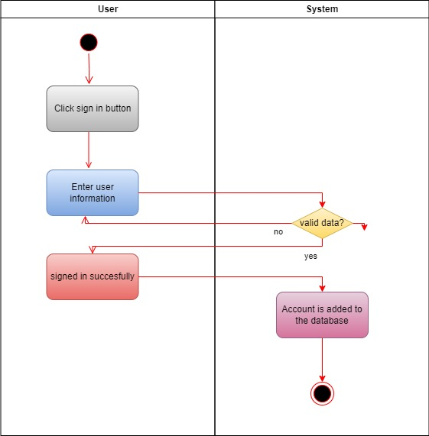Customer creates account

1. Items check

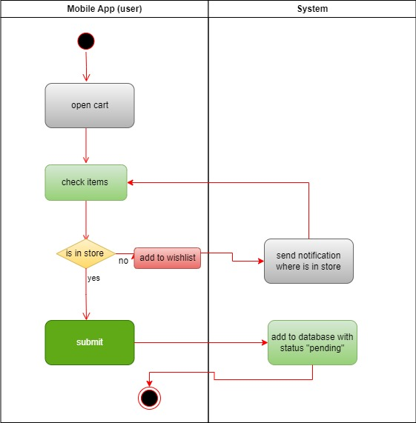

1. 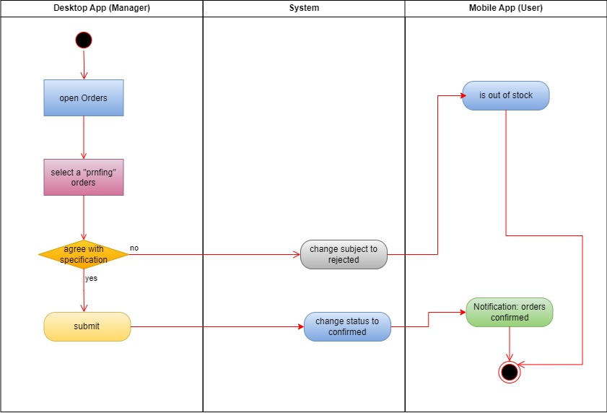Owner opens the orders
2. User log in

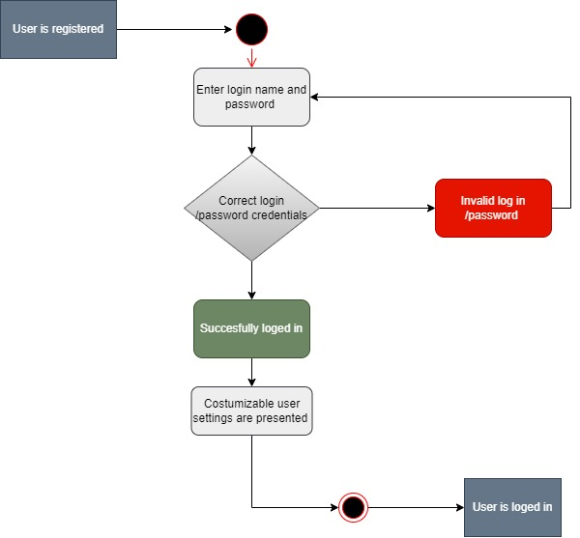  
  
  
  
  
  
  
  
  
  
  
  
  
  
  
  
  
  
  
  
  
  
  
  
  
  
  
  
  
  
  
  
  
  
  
  
  
  
  
  
  
  
  
  
  
  
  
  
  
  
  
  
  
  
  
  
  
  
  
  
  
  
  
  
  
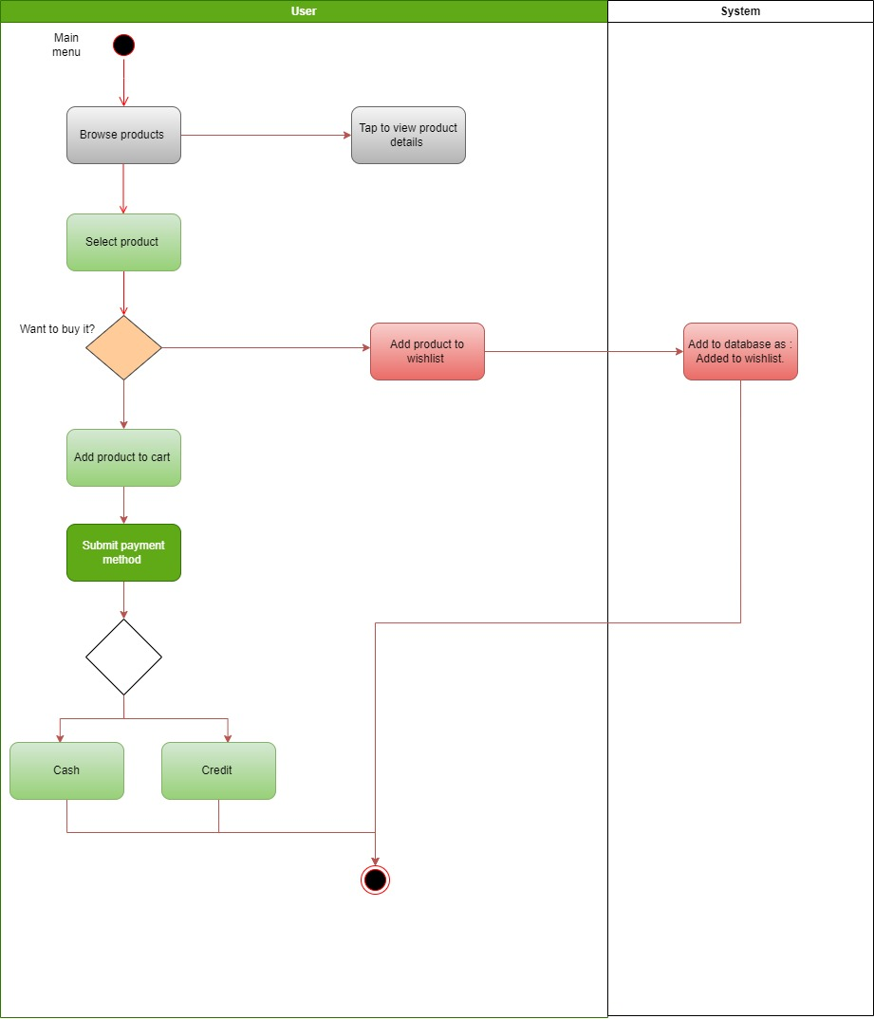5. Purchasing a product

6. Adding a new product   
  
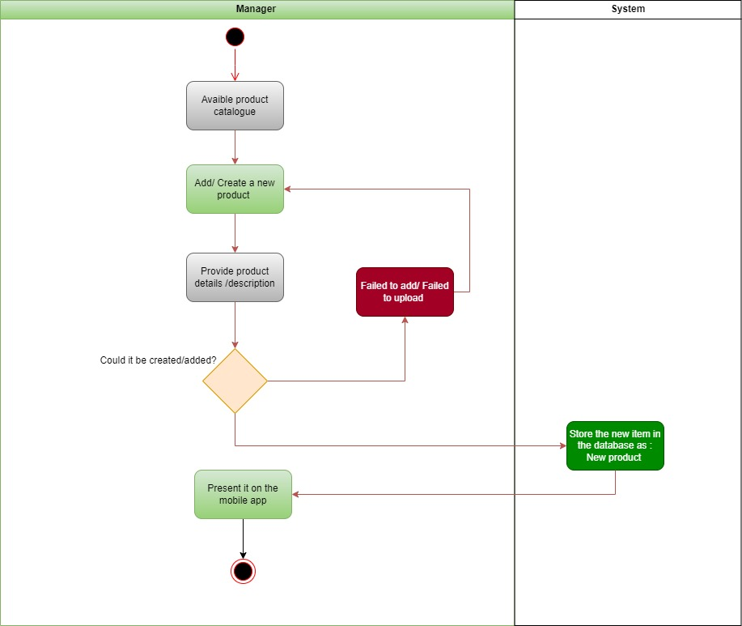  
  
  
  
  
  
  
  
  
  
  
  
  
  
7.Manager adding/removing/offering   
  
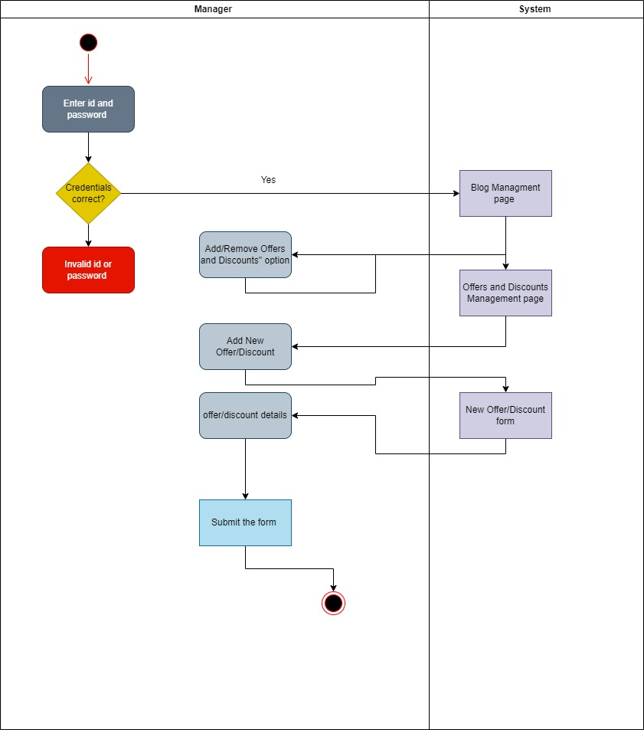  
  
  
  
  
  
8.Managing of the reports  
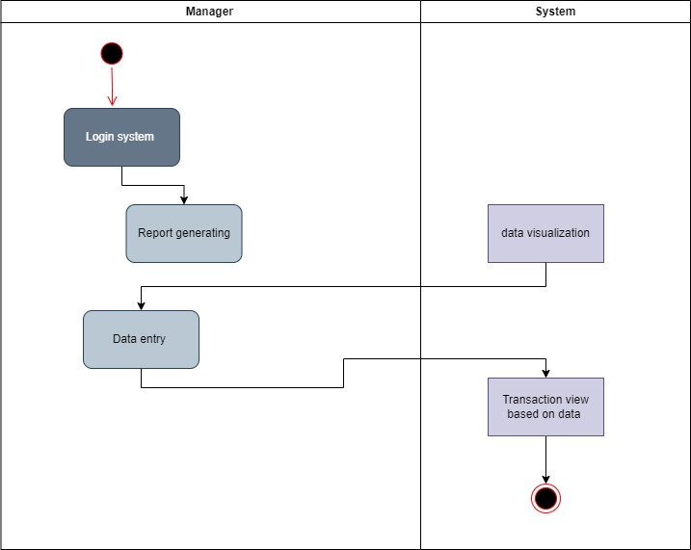  
  
  
  
  
  
  
  
  
  
  
  
  
  
  
  
  
9. Customer order tracking and product comparison   
  
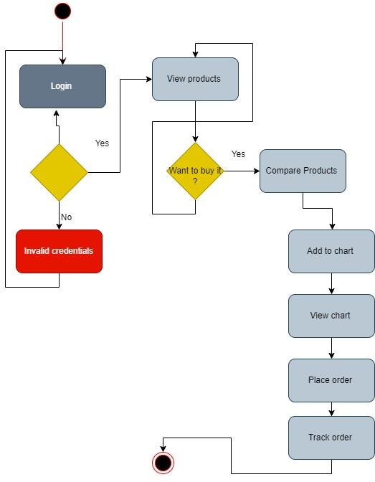

10. Clerk approve the order

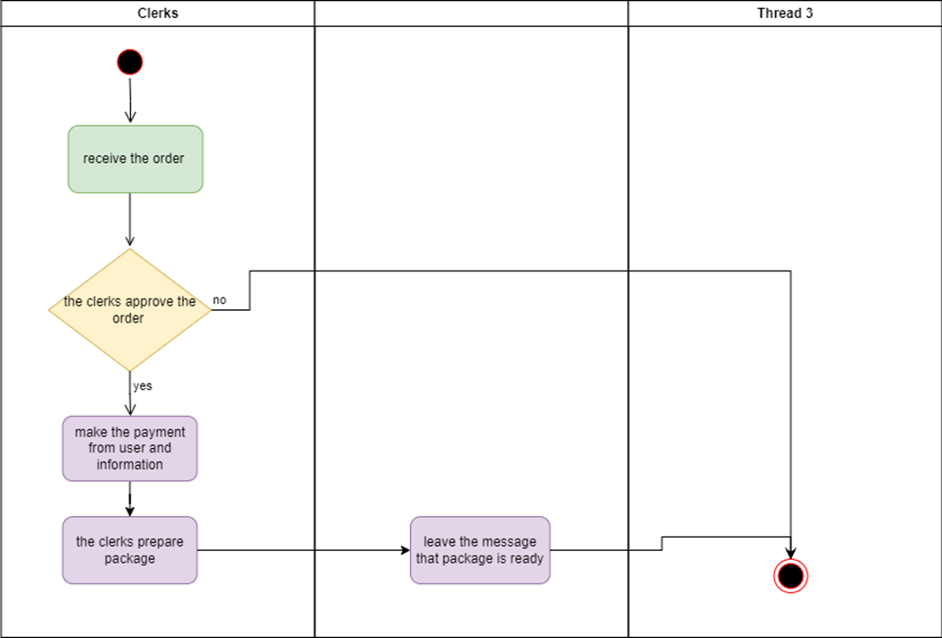

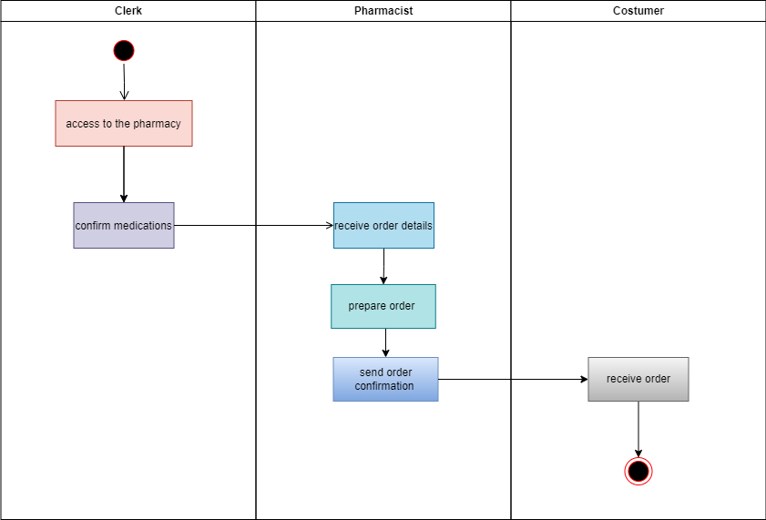11. System prepares order

* 1. ***State Machine Diagram***

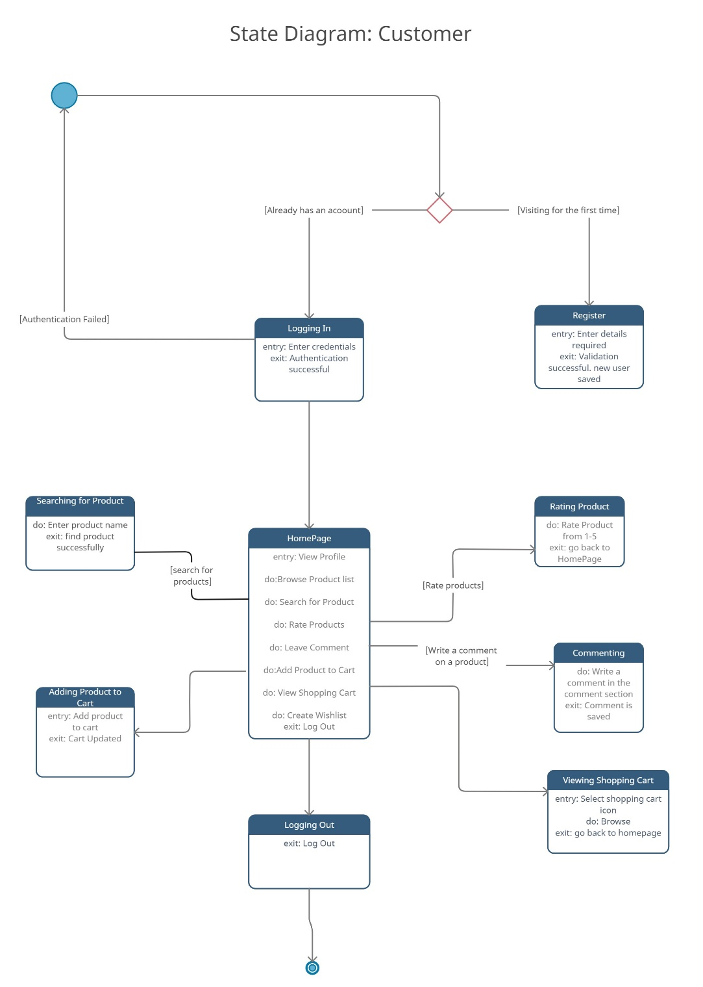1. Online customer

2. Store clerk

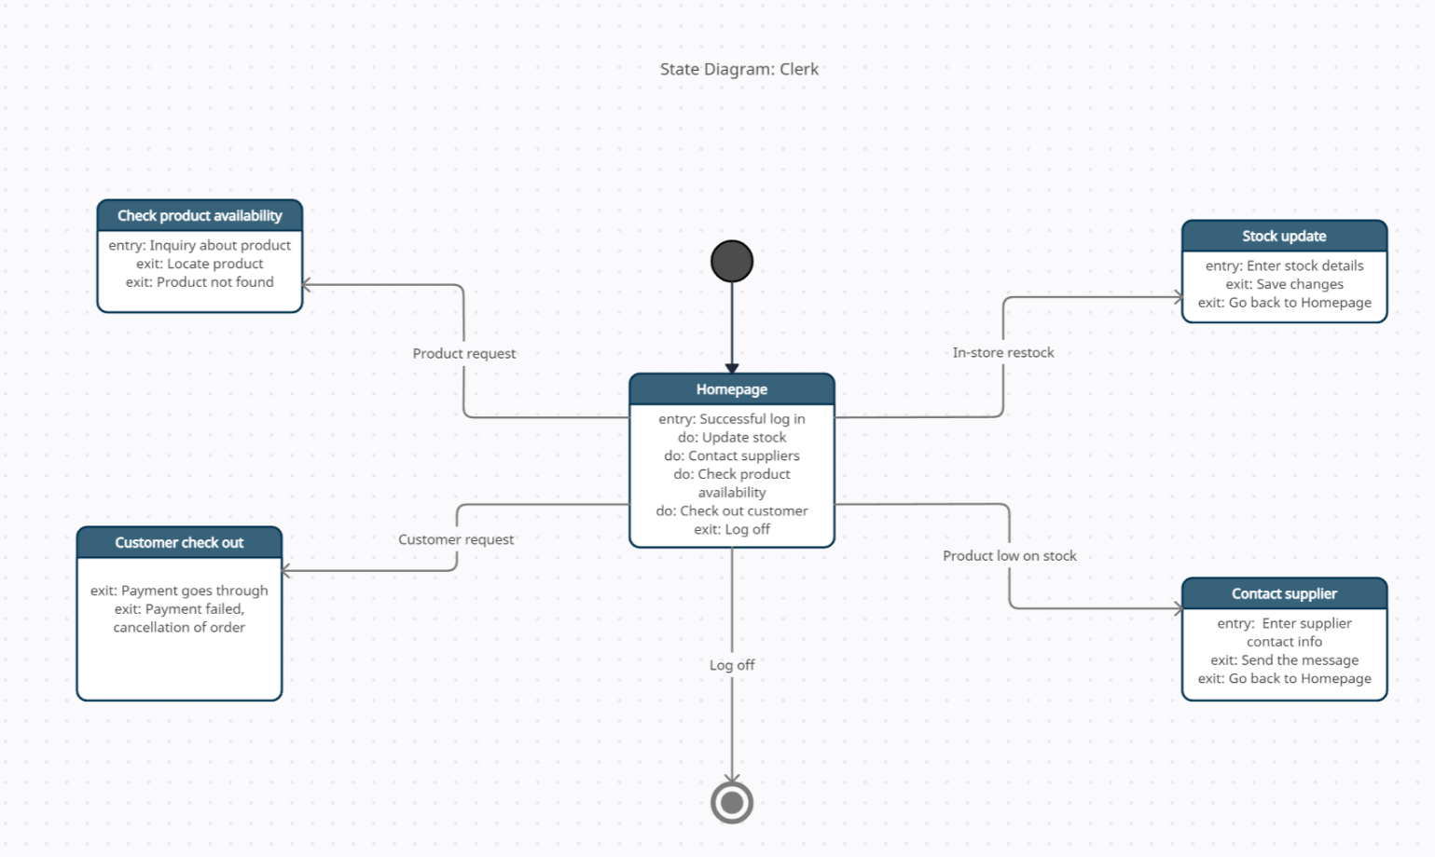

3. Manager

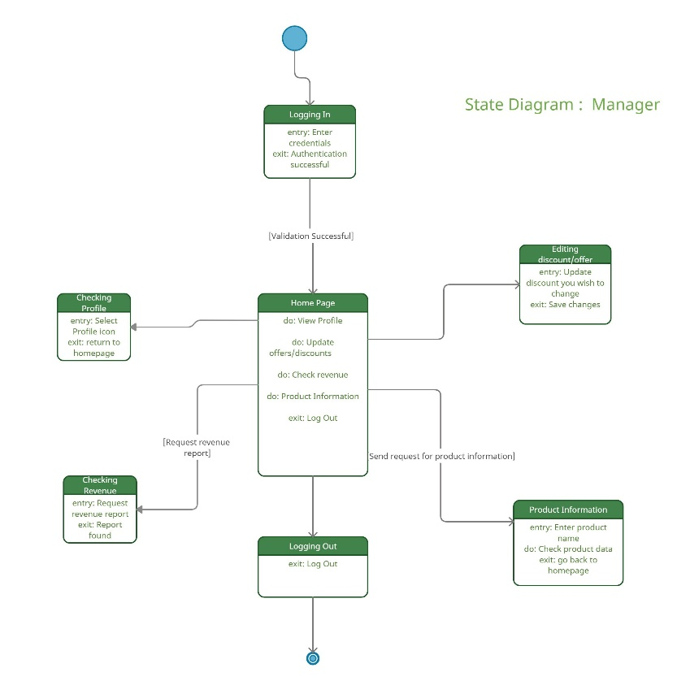

4. Admin/Owner

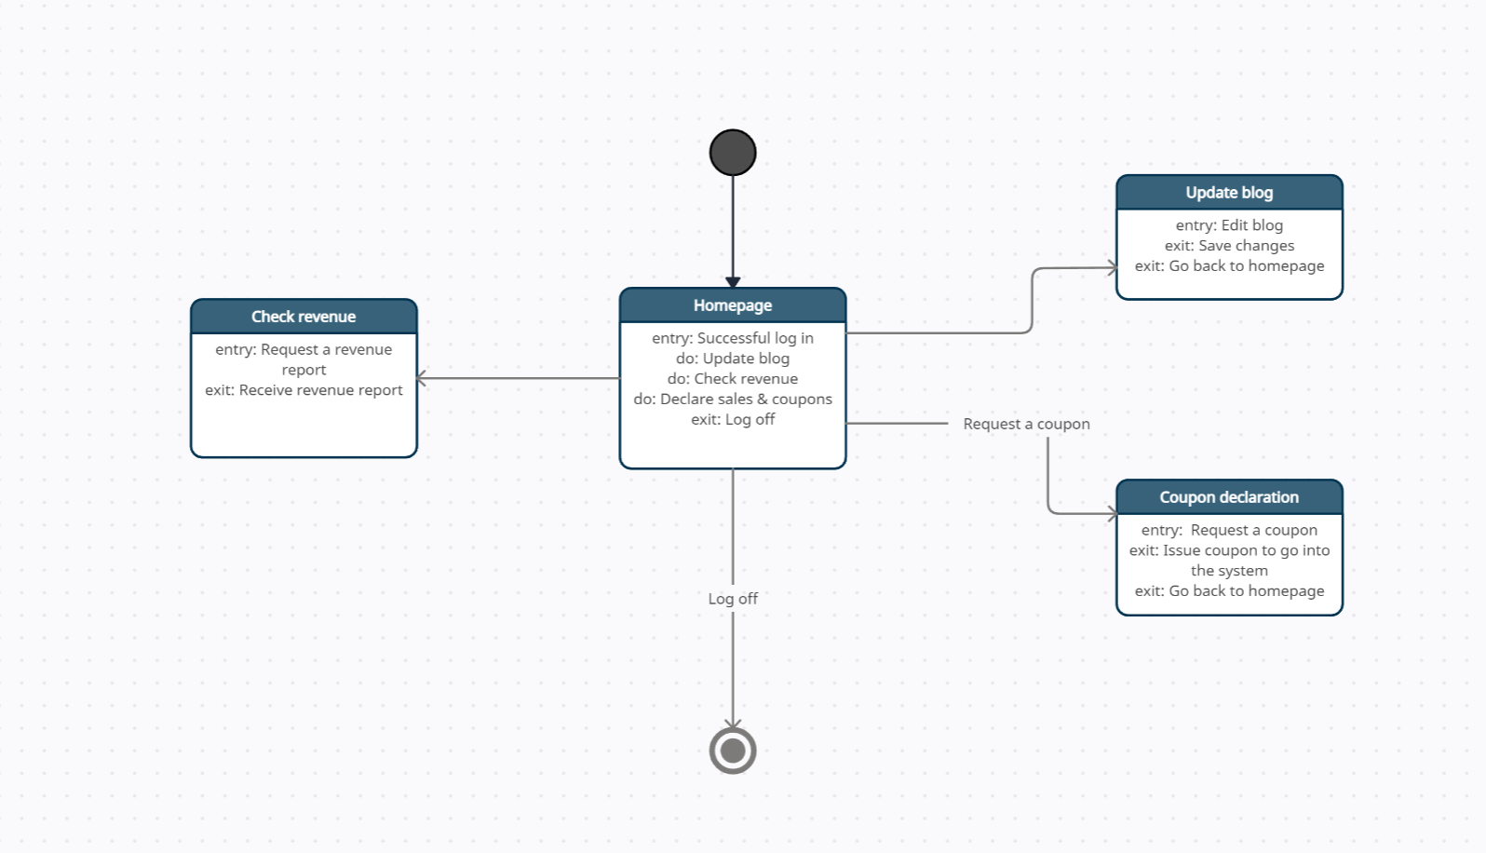

5. Check Out

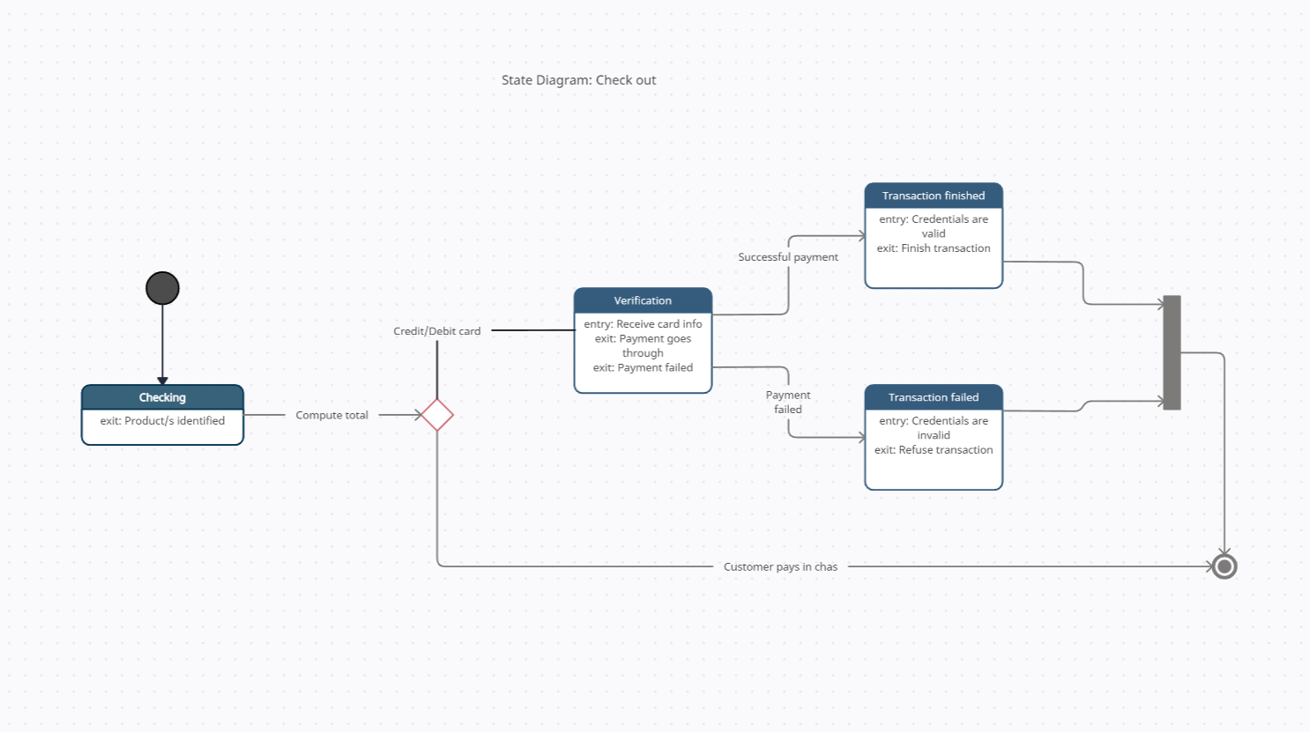

6. Wishlist

7. Checking Revenue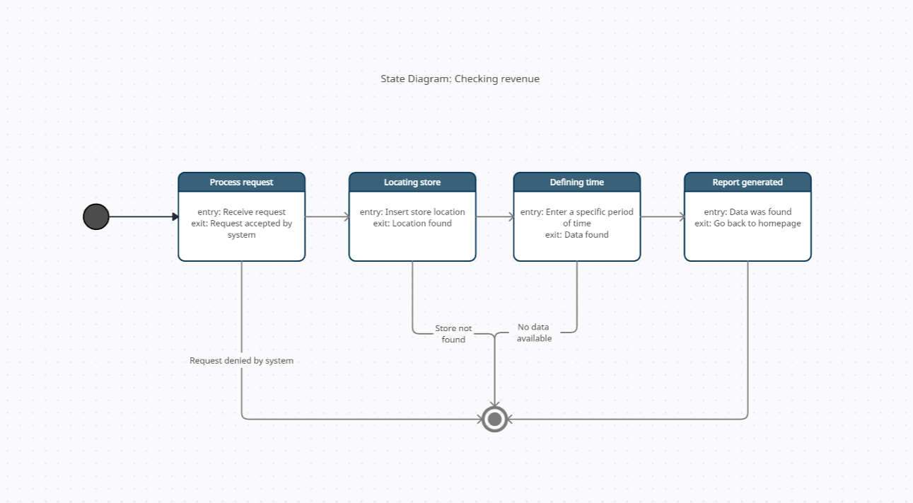

9. Login

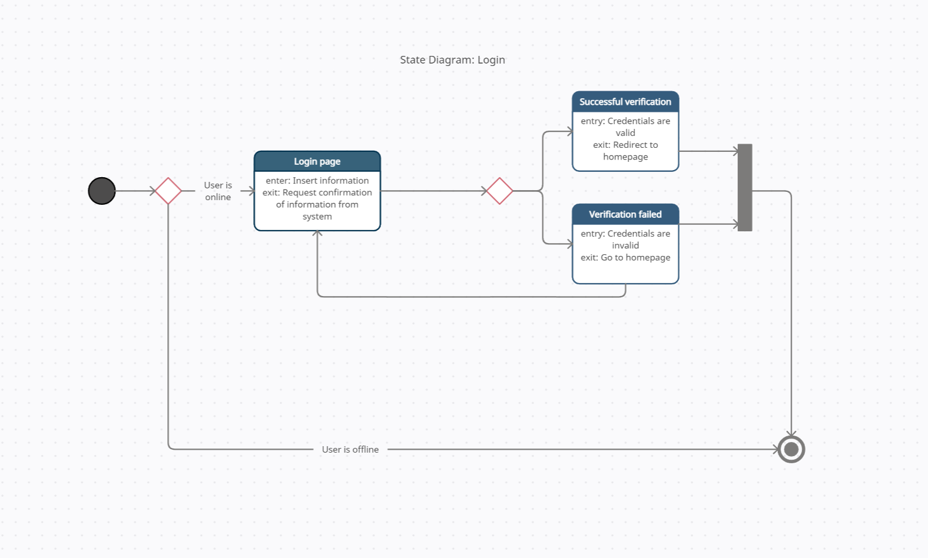

10. Sign Up

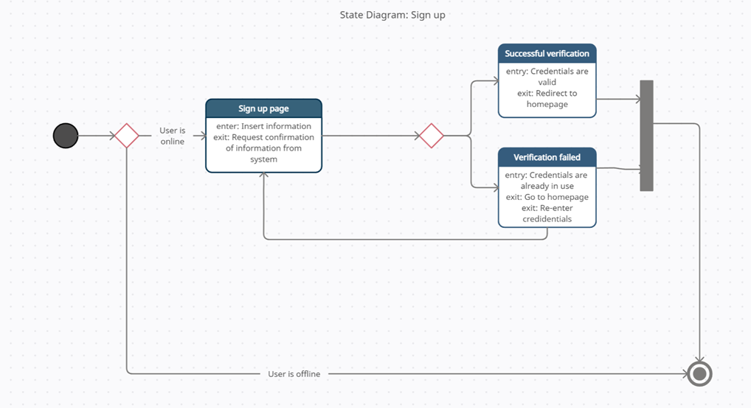

11. Placing an Order

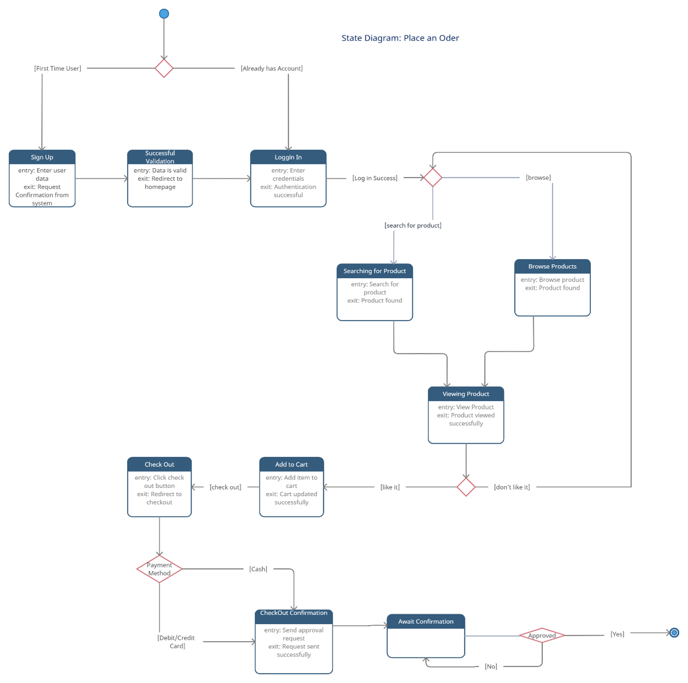

12. Product Managemnet

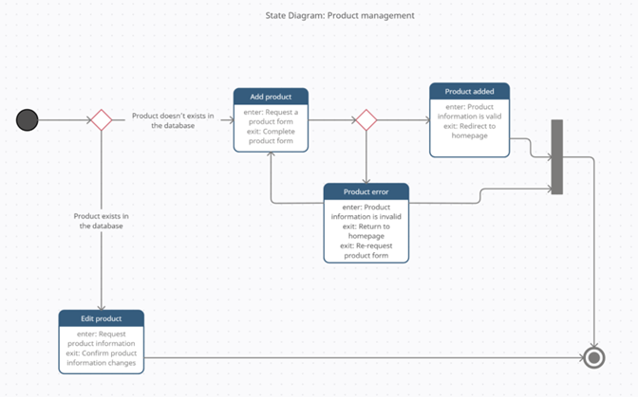

13. View Purchase History

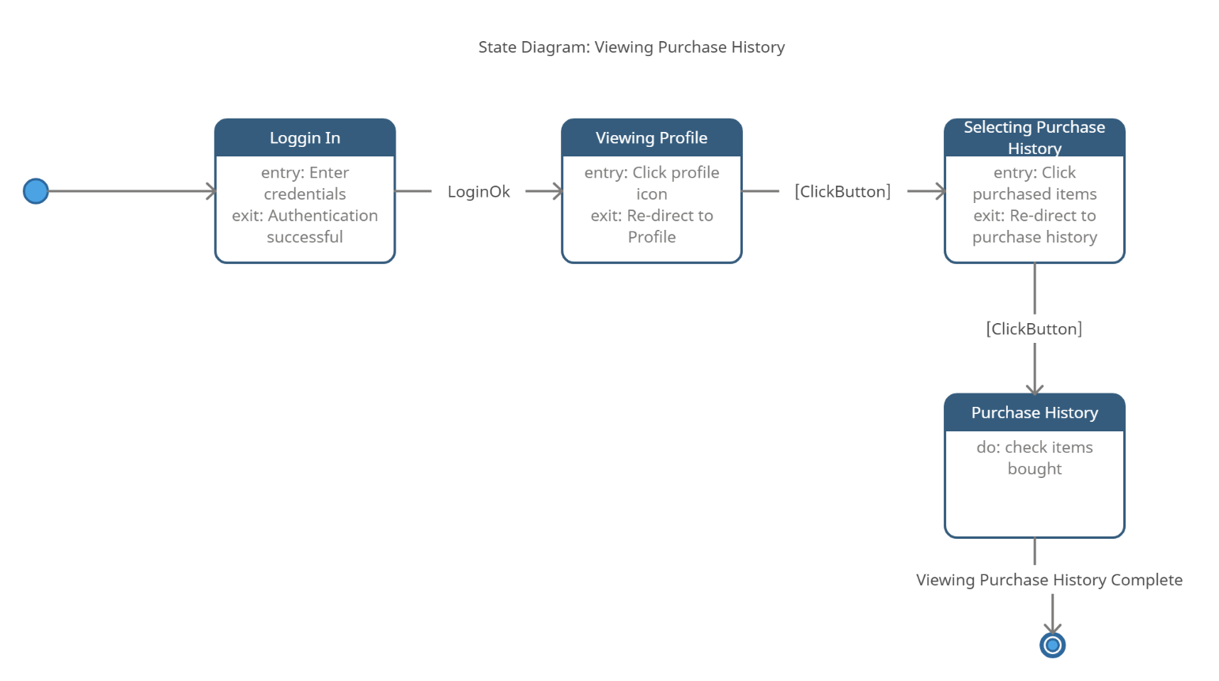

***4.4 Class Diagram***

1. A screenshot of a computer

   Description automatically generated with medium confidenceCustomer
2. Manager
3. A picture containing text, screenshot, diagram, plan

   Description automatically generatedOwner

1. Clerk

1. General

***4.5 Sequence Diagrams***   
  
***1.After user logs in and places an order***

***2. Customer Tracks an Order***  
  
  
  
  
  
  
  
  
  
  
  
  
  
  
  
  
  
  
  
***3. Customer Purchases a Product***  
  
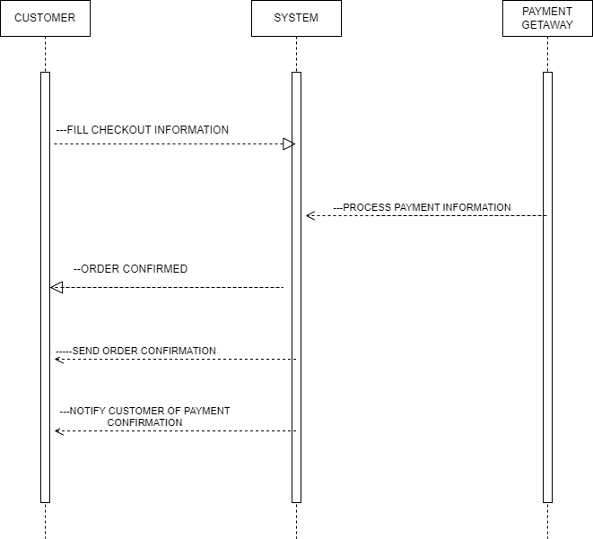  
  
  
  
  
  
  
  
  
  
  
  
  
***4.Managers check monthly sales report***

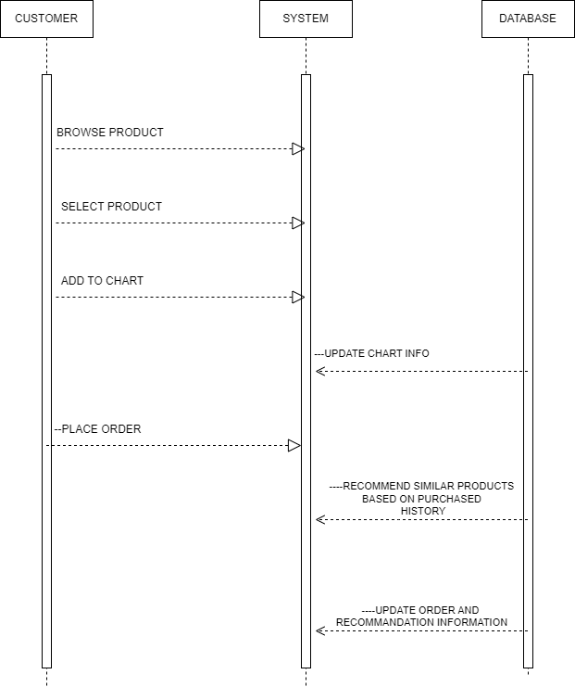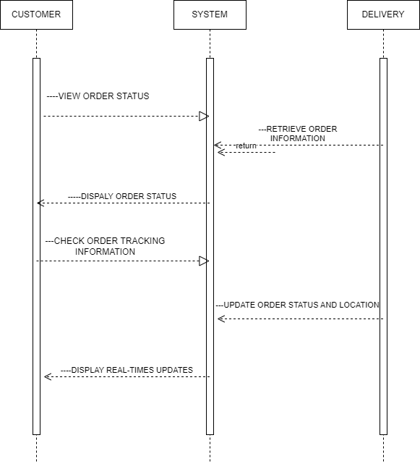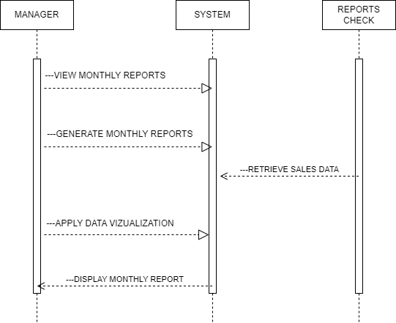

***5. Appointment***

***6 Admin modifies services***

***7. Preparing order***

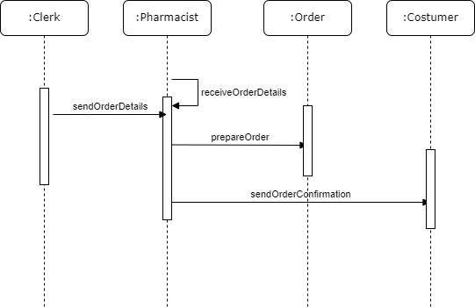

* 1. ***Communication Diagram***

APPENDIX

The appendixes are not always considered part of the actual Requirements Specification and are not always necessary. They may include

* Sample input/output formats, descriptions of cost analysis studies, or results of user surveys;
* Supporting or background information that can help the readers of the Requirements Specification;
* A description of the problems to be solved by the system;
* Special packaging instructions for the code and the media to meet security, export, initial loading, or other requirements.

When appendixes are included, the Requirements Specification should explicitly state whether or not the appendixes are to be considered part of the requirements.

1. **Definitions, Acronyms, and Abbreviations**

Define all terms, acronyms, and abbreviations used in this document.

1. **References**

List all the documents and other materials referenced in this document.

1. **Requirements Traceability Matrix**

The following trace matrix examples show one possible use of naming standards for deliverables (FunctionalArea-DocType-NN). The number has no other meaning than to keep the documents unique. For example, the Bargaining Unit Assignment Process Flow would be BUA-PF-01.

For example (1):

| **Business Requirement** | **Area** | **Deliverables** | **Status** |
| --- | --- | --- | --- |
| BR_LR_01  The system should validate the relationship between Bargaining Unit/Location and Job Class.---Comments: Business Process = "Assigning a Bargaining Unit to an Appointment" (Priority 1) | BUA | BUA-CD-01  Assign BU Conceptual Design | Accepted |
| BUA-PF-01  Derive Bargaining Unit-Process Flow Diagram | Accepted |
| BUA-PF-01  Derive Bargaining Unit-Process Flow Diagram | Accepted |
| BR_LR_09  The system should provide the capability for the Labor Relations Office to maintain the job class/union relationship.---Comments: Business Process = "Maintenance" (Priority 1) | BUA | BUA-CD-01  Assign BU Conceptual Design | Accepted |
| BUA-PF-02  BU Assignment Rules Maint Process Flow Diagram | ReadyForReview |

For example (2):

| **BizReqID** | **Pri** | **Major Area** | **DevTstItems DelivID** | **Deliv Name** | **Status** |
| --- | --- | --- | --- | --- | --- |
| BR_LR_01 | 1 | BUA | BUA-CD-01 | Assign BU Conceptual Design | Accepted |
| BR_LR_01 | 1 | BUA | BUA-DS-02 | Bargaining Unit Assignment DB Modification Description | Accepted |
| BR_LR_01 | 1 | BUA | BUA-PF-01 | Derive Bargaining Unit-Process Flow Diagram | Accepted |
| BR_LR_01 | 1 | BUA | BUA-UCD-01 | BU Assign LR UseCase Diagram | ReadyForReview |
| BR_LR_01 | 1 | BUA | BUA-UCT-001 | BU Assignment by PC UseCase - Add Appointment and Derive UBU | Reviewed |
| BR_LR_01 | 1 | BUA | BUA-UCT-002 | BU Assignment by PC UseCase - Add Appointment (UBU Not Found) | Reviewed |
| BR_LR_01 | 1 | BUA | BUA-UCT-006 | BU Assignment by PC UseCase - Modify Appointment (Removed UBU) | Reviewed |
| BR_LR_09 | 1 | BUA | BUA-CD-01 | Assign BU Conceptual Design | Accepted |
| BR_LR_09 | 1 | BUA | BUA-DS-02 | Bargaining Unit Assignment DB Modification Description | Accepted |
| BR_LR_09 | 1 | BUA | BUA-PF-02 | BU Assignment Rules Maint Process Flow Diagram | Accepted |
| BR_LR_09 | 1 | BUA | BUA-UCD-03 | BU Assign Rules Maint UseCase Diagram | Reviewed |
| BR_LR_09 | 1 | BUA | BUA-UCT-045 | BU Assignment Rules Maint: Successfully Add New Assignment Rule | Reviewed |
| BR_LR_09 | 1 | BUA | BUA-UCT-051 | BU Assignment Rules MaintUseCase: Modify Rule | Reviewed |
| BR_LR_09 | 1 | BUA | BUA-UCT-053 | BU Assignment Rules MaintUseCase - Review Assignment Rules | Reviewed |
| BR_LR_09 | 1 | BUA | BUA-UCT-057 | BU Assignment Rules MaintUseCase: Inactivate Last Rule for a BU | Reviewed |
| BR_LR_09 | 1 | BUA | BUA-UI-02 | BU AssignRules Maint UI Mockups | ReadyForReview |
| BR_LR_09 | 1 | BUA | BUA-TC-021 | BU Assignment Rules Maint TestCase: Add New Rule (Associated Job Class Does Not Exist) - Success | ReadyForReview |
| BR_LR_09 | 1 | BUA | BUA-TC-027 | BU Assignment Rules Maint TestCase: Modify Rule - Success | ReadyForReview |
| BR_LR_09 | 1 | BUA | BUA-TC-035 | BU Assignment Rules Maint TestCase: Add New Rule (Associated Job Class Does Not Exist) - Error Condition | ReadyForReview |
| BR_LR_09 | 1 | BUA | BUA-TC-049 | BU Assignment Rules Maint TestCase: Modify Rule - Error Condition | ReadyForReview |

For example (3):

| **BizReqID** | **CD01** | **CD02** | **CD03** | **CD04** | **UI01** | **UI02** | **UCT01** | **UCT02** | **UCT03** | **TC01** | **TC02** | **TC03** | **TC04** |
| --- | --- | --- | --- | --- | --- | --- | --- | --- | --- | --- | --- | --- | --- |
| BR_LR_01 |  |  | X |  | X |  | X |  |  | X |  | X |  |
| BR_LR_09 | X |  |  | X |  | X |  |  | X |  | X |  | X |
| BR_LR_10 | X |  |  | X |  |  |  |  | X |  | X |  |  |
| BR_LR_11 |  | X |  |  |  |  |  |  |  |  |  |  |  |

1. **Organizing the Requirements**

This section is for information only as an aid in preparing the requirements document.

Detailed requirements tend to be extensive. Give careful consideration to your organization scheme. Some examples of organization schemes are described below:

**By System Mode**

Some systems behave quite differently depending on the mode of operation. For example, a control system may have different sets of functions depending on its mode: training, normal, or emergency.

**By User Class**

Some systems provide different sets of functions to different classes of users. For example, an elevator control system presents different capabilities to passengers, maintenance workers, and fire fighters.

**By Objects**

Objects are real-world entities that have a counterpart within the system. For example, in a patient monitoring system, objects include patients, sensors, nurses, rooms, physicians, medicines, etc. Associated with each object is a set of attributes (of that object) and functions (performed by that object). These functions are also called services, methods, or processes. Note that sets of objects may share attributes and services. These are grouped together as classes.

**By Feature**

A feature is an externally desired service by the system that may require a sequence of inputs to affect the desired result. For example, in a telephone system, features include local call, call forwarding, and conference call. Each feature is generally described in a sequence of stimulus-response pairs, and may include validity checks on inputs, exact sequencing of operations, responses to abnormal situations, including error handling and recovery, effects of parameters, relationships of inputs to outputs, including input/output sequences and formulas for input to output.

**By Stimulus**

Some systems can be best organized by describing their functions in terms of stimuli. For example, the functions of an automatic aircraft landing system may be organized into sections for loss of power, wind shear, sudden change in roll, vertical velocity excessive, etc.

**By Response**

Some systems can be best organized by describing all the functions in support of the generation of a response. For example, the functions of a personnel system may be organized into sections corresponding to all functions associated with generating paychecks, all functions associated with generating a current list of employees, etc.

**By Functional Hierarchy**

When none of the above organizational schemes prove helpful, the overall functionality can be organized into a hierarchy of functions organized by common inputs, common outputs, or common internal data access. Data flow diagrams and data dictionaries can be used to show the relationships between and among the functions and data.

**Additional Comments**

Whenever a new Requirements Specification is contemplated, more than one of the organizational techniques given above may be appropriate. In such cases, organize the specific requirements for multiple hierarchies tailored to the specific needs of the system under specification.

There are many notations, methods, and automated support tools available to aid in the documentation of requirements. For the most part, their usefulness is a function of organization. For example, when organizing by mode, finite state machines or state charts may prove helpful; when organizing by object, object-oriented analysis may prove helpful; when organizing by feature, stimulus-response sequences may prove helpful; and when organizing by functional hierarchy, data flow diagrams and data dictionaries may prove helpful.